**Spam Classifier for YouTube Comments**

**202310603 Hyunjoon Kim (김현준)**

Abstract

Throughout the world of internet, classifying spam contents has become one of the crucial features for website owners. YouTube is one of the biggest platforms not only guarantees the accessibility of leaving comments to the users, but also watching other’s comments. It refers that it is a juicy prey for someone running a business which is harmless or harmful for others. This paper covers YouTube’s real time comments collection using YouTube Data API, and comments ham or spam classification using machine learning technique. Using Random Forest machine learning technique, the model detected some spam comments.

Introduction

YouTube is the biggest video sharing platform that allows users to leave their thoughts, ideas, or emotions. However, unlike the average users, there are distinctively harmful comments for their profit that could distract the average users. Based on that, managing advertisements or scam contents on comment section is one of the crucial tasks for keeping the number of users and their income. Indeed, YouTube, one of the largest video platforms, is well managing the spam contents by using its classification model and tremendous amount of data. However, for the companies that are small, collecting that amount of data might be impossible. Moreover, with the lack of computing systems, building and training a model could be competitive to the spam classifier from YouTube would be in the dream for them. A solution for that is building small and compact model that could not be the best but works well for too obvious spam contents.

For classification model, building a neural network model is one of the cases. However, for this paper, I focused on simple machine learning techniques. The reason for that is I want this classifier could be an initial solution, and the owner would be able to develop it afterward, based on the result of this classifier.

Firstly, I used basic spam classification dataset from Kaggle. With that dataset, we would like to be able to train the model the basic format of spam content. Also, I used AI-generated Gen-Z slang comments dataset from Chat-GPT so that model will be able to recognize the slangs from recently written comments. For the preprocessing of the dataset, I used Porter’s Stemmer for stemming and TF-IDF Vectorizer for vectorization. Next, for the model, I used Random Forest (RF) Classification model. RF is a machine learning technique uses ensemble method that combines multiple base models to make the high accuracy and precise predictions. Especially for spam content classification, it is one of the recommended solutions.

2. Related Works

For spam detection, plenteous amount of research papers, projects and studies exist using machine learning techniques regardless of platform. [Spam email detection using machine learning](https://medium.com/@azimkhan8018/email-spam-detection-with-machine-learning-a-comprehensive-guide-b65c6936678b" \t "_blank) on Medium,[Same method](https://github.com/kanagalingamsm/Email-Spam-Detection" \t "_blank) on GitHub, and [SMS spam detection](https://www.kaggle.com/code/amirhosseinmirzaie/simple-sms-spam-detection-text-classification" \t "_blank) on Kaggle. That means spam detection is a hot topic, and it is crucial and valuable for people.

3. Proposed Methods

For classifying spam comments, Naïve Bayes is one of the suitable but also popular methods. However, Based on the test results from [Spam detection for YouTube video comments using machine learning approaches](https://www.sciencedirect.com/science/article/pii/S2666827024000264" \l "sec1" \t "_blank), it is showing that Random Forest showed the highest F1-score recorded 0.962… . Whereas Naïve Bayes method showed lowest accuracy score recorded 0.852… . Therefore, I thought using a Random Forest solution would be highly recommended for spam detection. To classify the natural language, the human language in the other words, vectorizing method must be presumed. Thus, for the vectorizing method, there are several methods such as Bag of Words, Tf-Idf, and Word2Vec. For this project, I thought Word2Vec method is too sophisticated, and Tf-idf vectorizing method should be precisely work for spam detection. Since we are counting the frequencies of the words, removing grammatical part of the word and leaving the stem of the words would work effectively. For this effective method, I used Porter's Stemming algorithm, which is the well known stemming method. Lastly, for the evaluation method, I chose F1-score. F1-score includes Precision score and Recall score for calculation, which fits for binary classification methods.

3.1. Stemming Algorithm

Stemming is a method for processing text-based data by eliminating prefixes and suffixes so that the model only interprets the fundamental part of the word. In simple word, it is clensing grammars from words. I chose [Porter’s Stemmer](https://tartarus.org/martin/PorterStemmer/" \t "_blank) for the project, one of the most popular stemming algorithms proposed in 1980. Example of Porter’s Stemmer is this. Suppose we have *‘running’*, *‘jumps’*, *‘happily’*, and *‘running’* as original words. After stemming those words, those will turn to *‘run’*, *‘jump’*, *‘happili’*, and *‘run’*. That will make difference in terms of calculating frequency in vectorization term.

3.2. Vectorization of Comments Using *TF-Idf Vectorizer*

*TF-Idf Vectorizer*, a vectorizing method for natural languages which is based on frequency, in other words, it is counting how many sentences are including a certain word. TF-IDF Vectorizer is an advanced method of Bag of Words, and the difference between those two methods is that *TF-Idf vectorizer* excludes the conjunctions such as preposition or article, so that we could ignore the most frequently used words regardless with the intension of the sentences. That means it is appropriate for spam classification detecting model.  
*Tf-Idf vectorizer* shows its calculation by its name, which is:

$$TF IDF=Term Frequency *log⁡( \frac{number of Document}{Document Frequency })$$

*TF,* which stands for *Term Frequency*, is a vector of counted words how many times showed in a certain sentence. Suppose we have a sentence *“banana apple apple orange.”*. If it is the only sentence in the dataset, Term Frequency of this sentence is going to be

$$TF of 1st Document=(1, 2,1)$$

Meaning that except the word *‘apple’*, the other words have shown only once in the example sentence.

Suppose that we have more sentences *“apple carrot eggplant carrot” and “banana mango orange orange”*. In this case, the new words are going to be stored last in the vector, and the words already exist inside of TF will add the number of its position. $$Vocabulary=\left(2,3,3,2,1,1\right)$$

$$TF of 2nd Sentence=\left(0,1,0,2,1\right)$$

$$TF of 3rd Sentence=\left(1,0,2,0,0,1\right)$$

As we can see Vocabulary, the words *‘apple’* and *‘orange’* is showing high frequency compared to the other words. Let’s suppose the 2nd Sentence is a spam comment. If we give these vectors, classifier would likely be confused, because there is not any distinctive difference. which are going to be conjunctions and article etc. in real life. To solve this problem, IDF which stands for Inversed Document Frequency is required.

DF counts how many sentences included the certain word. For instance, the vector of DF is going to be $$DF=(2,2,2,1,1,1)$$

High values inside of DF inherent that it has a possibility that it is a conjunction or article etc. Now, since the values in DF must be inversed so that model could ignore the high values inside of DF. In conclusion, applying it to an equation, the final vectors are going to be

$$IDF= \frac{number of Document}{DF} =(1.5,1.5,1.5,3,3,3)$$

$$TF*IDF of 1st Sentence=\left(1.5, 4.5, 1.5, 0, 0, 0\right)$$

$$TF*IDF of 2nd Sentence=\left(0, 1.5, 0, 6, 3, 0\right)$$

$$TF*IDF of 3rd Sentence=(0.5, 0, 3, 0, 0, 3)$$

After calculating TF-IDF, compare to TF vectors, since we supposed that the 2nd sentence is the spam, model will give a high score if the new sentence contains the word *‘carrot’* and *‘eggplant’*.

3.3. Classifying Spam Comments by Using Machine Learning Method

For classification method. As I mentioned at 3., I chose RF classification method which showed highest result among the classification methods. Random Forest leverages the strength of decision trees and ensemble learning. By constructing multiple trees, each trained on different subsets of the data, and aggregating their predictions through averaging, Random Forest mitigates the over-fitting of individual trees.

3.4. Evaluation of Spam Comment Classifier

In binary classification, results are divided True Positive (TP), True Negative (TN), False Positive (FP), False Negative (FN). With each result, calculating score of the model such as ‘F1-Score’, ‘Precision Score’ or ‘Accuracy’ would be calculated by those values. For spam classification, I thought both precision score and recall score are crucial for spam detection. Therefore, I chose F1-score as an evaluation method for my model. F1-score calculates harmonic mean between Precision Score and Recall Score.

4. Experiment and Result Analysis

For implementation, I chose 2 datasets from Kaggle and AI to train the model. A dataset from Kaggle highly used for basic Natural Language Process (NLP), but the comments consisting of the dataset are outdated. To classify recent comment data, I decided to use AI generated dataset that contains slangs. With that solution, the model would be able to classify the slangs in the comments.

4.1. Dataset

Datasets are formed in data table having two columns, Comment and Class. The dataset from Kaggle had 1956 rows, and well distributed class as we can see in Fig1.

Fig 1. Class Distribution of dataset from Kaggle.

Meanwhile, for AI generated Dataset, I used [prompt](https://chatgpt.com/share/674d7142-da30-8000-89ea-f4ced7c6b562) below this sentence to get a dataset.

*“****User :***

*could you make a 1,000 of Youtube comment data which has 2020-2024's slangs for spam binary classification? dataset must be look like this*

*```csv*

*comments,class*

*```*

*If the comment has the link, please generate the link by your self. Make sure all the comments are unique in the dataset”*

Even though I got the dataset looks fine, I had to exclude the numerous duplicated ham comments from dataset. As a result for that, I got imbalanced dataset. However, since we are using RF algorithm which takes subsets from the dataset, it would not be a crucial problem.

Fig2. Class distribution of AI generated Dataset

4.2 Training & Testing the Model

To choose the hyper parameters for both TF-IDF vectorizer and RF Classifier, I decided to use cross validation method so that I could save tons of time. I used [Randomized Cross Validation](https://scikit-learn.org/1.5/modules/generated/sklearn.model_selection.RandomizedSearchCV.html) since we are using numerous amounts of dataset for training. Cross validation method is iterating the possible parameter settings given by user. For the parameters of [TF-IDF vectorizer](https://scikit-learn.org/1.5/modules/generated/sklearn.feature_extraction.text.TfidfVectorizer.html), I chose *‘lowercase’*, *‘max\_df’*, *‘max\_features’*, and *‘min\_df’*. Also, for [RF classifier](https://scikit-learn.org/1.5/modules/generated/sklearn.ensemble.RandomForestClassifier.html), I chose *‘max\_depth’*, *‘max\_features’*, and *‘n\_estimators’*. The explanation for these hyper parameters is on *Scikit-learn* documentation. Through this cross validation, I got 0.95 for f1-score on Kaggle dataset, 1.0 for AI generated dataset.

Fig 3. Model Diagram for Kaggle Dataset

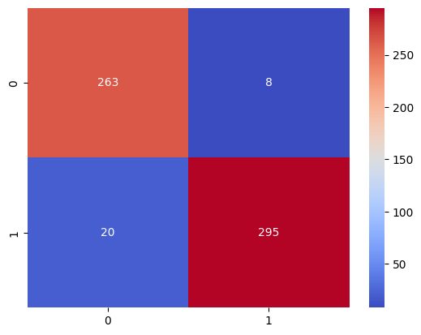

Fig 4, 5. Confusion Matrix for Kaggle Dataset(left), AI generated Dataset(right)

Fig 6. Classification Report for Kaggle Dataset

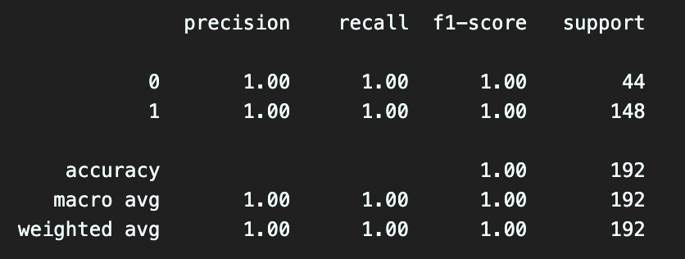

Fig 7. Classification Report for AI generated dataset

Fig 8, 9. F1 Score of each Thresholds and ROC curve for Kaggle Dataset(left) and AI generated Dataset(right)

4.3 Application to Real YouTube Comments

Good model works for real data. For this case, grabbing real comments from YouTube and classifying with the model would be the precise validation for our model. Unfortunately, spam comments classified by YouTube are not allowed because of the [policy](https://developers.google.com/youtube/v3/docs/comments/markAsSpam). However, recent comments imply possibility that those are not blocked yet. Fortunately, [YouTube Data API](https://developers.google.com/youtube/v3/docs/commentThreads/list) provides the example of use which is written in various programming languages that they support, including python. With that code, I wrote a function calls an API and returns the list of comments. For the next step, I marked a thousand of comments. However, only 7 comments were spam in my perspective, and the purposes of the comments marked spam were ambitious. Before the test, I concatenated Kaggle Dataset and AI Generated Dataset. A screenshot of a computer code

Fig 10. Model Diagram for concatenated dataset

Fig 11. Classification Report for concatenated dataset

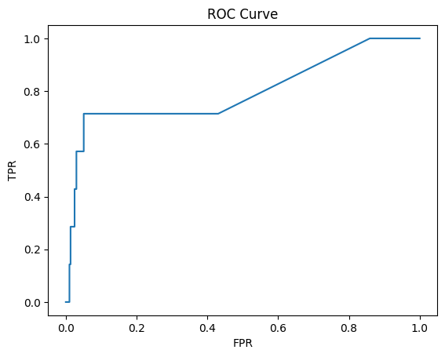

Fig 12, 13. Confusion Matrix (left) ROC Curve (right) for concatenated dataset

As we can see the result, the model recorded low F1-score of classifying spam comments. However, it was working properly for 4 spam comments. I will leave the four comments below this sentence.

*“Glorilla continues to release incredible music! Sexy Red also appeared in HAM! After they discovered the SHORT on my channel describing how all of those artists are currently becoming so successful, they both significantly advanced in their professions.”*

*“"The song 🗿\nThe creator 🗿\nThe instrumental 🗿\nThe viewers 🗿\nThe song listener🗿\nThe saver of the song🗿\nThe one who added this song in his playlist 🗿\nThe one*

*… (repeating) …*

*writing this🗿\nThose who have the hearing ability to listen to this song🗿\nGuys it takes alot of time pls subscribe to me 😢😢and like me 😢*

*If u find my comments subscribe to me"*

*“Please pin me! These are one of my favorite videos to watch! They make me laugh! 😊'”*

*"Hello, I was wondering, if I can share with you the most important thing. God the Father sent His holy Son Jesus to earth, to be born of a virgin.*

*… (religious content) …*

*We all must sincerely receive Jesus into our life to be God's child. See John 1:12 for this please. Will you today genuinely by faith receive Jesus into your life for salvation?”*

4.4. Analyzing the Result

Even though it was not quite a successful result, because of its purpose, for small companies that are not affordable for high computation for training, It is an appropriate model. Firstly, the time recorded 50.2 second to train the concated dataset for my local environment(Macbook M3 Pro). For small companies, I would like to say that it is affordable time to train that they could wait for. Second of all, this model is affordable. To use other’s spam classification model, according to [OOPSpam](https://www.oopspam.com/#pricing), it costs $40 per month for 100,000 of API call. However, for someone who is trying to open their new websites, it is a hard decision to buy an API for spam detection. Lastly, it works. Even though it is not a perfect model, it did detect some comments with passing most of the ham comments. Also, training time was also nearly a minute, that means we can improve the model with collecting more data while running the service. In conclusion, the model didn’t record high accuracy, but it must be suitable for individuals.

5. Conclusion

For this Learning Concert, I made spam detector for YouTube comments, and I focused on making it for the small companies. As a result, I got the model with 0.96 and 0.97 of predicting test comments and real ham comments. However, the model was recording 0.13 f1-score for the spam contents. Even though it is not a great model, given its computation time and working fine for ham contents, it is true that it would like to be applied for small company’s website or programs.

6. References

[1] [Email Spam Detection with Machine Learning: A Comprehensive Guide](https://medium.com/@azimkhan8018/email-spam-detection-with-machine-learning-a-comprehensive-guide-b65c6936678b) by Azim Khan

[2] [Email Spam Detection using Machine Learning](https://github.com/kanagalingamsm/Email-Spam-Detection) by Kangalingamsm

[3] [Spam detection for Youtube video comments using machine learning approaches](https://www.sciencedirect.com/science/article/pii/S2666827024000264#sec1) by Andrew S. Xiao a, Qilian Liang b

[4] [The Porter Stemming Algorithm](https://tartarus.org/martin/PorterStemmer/) by Martin Porter

[5] [Randomized CV in SKlearn](https://scikit-learn.org/1.5/modules/generated/sklearn.model_selection.RandomizedSearchCV.html)

[6] [TF-IDF in SKlearn](https://scikit-learn.org/1.5/modules/generated/sklearn.feature_extraction.text.TfidfVectorizer.html)

[7] [Random Forest Classifier in SKlearn](https://scikit-learn.org/1.5/modules/generated/sklearn.feature_extraction.text.TfidfVectorizer.html)

[8] [YouTube Data API](https://scikit-learn.org/1.5/modules/generated/sklearn.feature_extraction.text.TfidfVectorizer.html) in Google Cloud API Service

[9] [OOPSpam](https://www.oopspam.com/#pricing)